Memo to Members:
Communicating with Excellence
  - A guide for STC Florida Newsletter Editors
  - Last Updated: 16 May 2018
Table of Contents
Introduction 2
Getting Started 2
Planning Your Publication Cycle 3
The Mission of MtM 3
Scheduling Made Simple 3
Newsletter Publication Date 3
Writer Feedback Deadline 4
Editorial Recommendations Deadline 4
Article Submission Deadline 4
Articles for the Newsletter 5
Table of Contents 5
From the Editor’s Desk 5
The President’s Corner 5
This Month’s Meeting 5
If You Missed the Last Meeting 5
Feature Articles 6
Occasional Guest Columns 6
New Columns on the Horizon?! 6
Newsletter Publication (WordPress) 7
Drafting an MtM Volume 7
Publishing an MtM Volume 14
Newsletter Distribution (MailChimp) 15

Introduction
If you are reading this, then you are probably a newly-appointed Newsletter Editor and/or Communications Committee member for STC Florida. Congratulations, and thank you in advance for your service! Your work with the newsletter will be critical to chapter meeting attendance and the successful engagement of technical communicators throughout Florida (and beyond).
This guide is designed to explain all functions related to our Memo to Members (MtM) newsletter. Many of these tasks will fall to the Newsletter Editor, but not necessarily all of them. Our chapter’s Communication Strategy describes the breakdown of communications responsibilities in greater detail.
There will always be something new to learn with MtM, as with all chapter operations. Whenever a newsletter process is introduced or updated, please incorporate the new information into this guide. Your successors will benefit greatly.

Getting Started
Before you begin, you will want to ask your teammates within the chapter for admin-level access to some or all of the following accounts:
- MtM Wordpress (for drafting and publication of MtM volumes)
  - When you log in for the first time, you will be able to change your password in the Users Your Profile menu on the Dashboard.
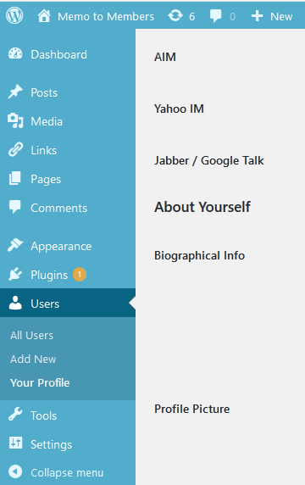
- STC Florida MailChimp (for email distribution of published MtM volumes to our target audiences)
- STC Florida Facebook (for further advertisement of published MtM volumes)

Planning Your Publication Cycle
Publishing the newsletter may seem daunting at first, but it becomes routine after a few months of practice. Careful planning for your first volume of MtM is an excellent place to start.

The Mission of MtM
Above all, the goal of MtM is to deliver a timely advertisement and reminder for each month’s chapter meeting. This typically means that you will publish 11 volumes of MtM per year, with a one-month break in July since there is no July meeting. The volumes preceding and following our annual joint Future Technical Communicators (FTC)/STC meeting at the University of Central Florida (UCF) will typically be the most extensive and involved. This is usually our main event of the year, and it is usually in February.

Scheduling Made Simple
You will want to address the following milestones for each volume of MtM:
- Article Submission Deadline
- Editorial Recommendations Deadline
- Writer Feedback Deadline
- Newsletter Publication Date
Since MtM’s mission stems from monthly chapter meetings (typically held on the third Thursday of each month), it helps to build your schedule in reverse chronological order.

Newsletter Publication Date
You should aim to publish each edition of MtM approximately seven days prior to the next chapter meeting. Do not publish more than 10 days prior, or the urgency of your message may be lost in translation. If unforeseen circumstances arise, it is acceptable to publish with as little as two to four days’ advance notice (preferably three to four).
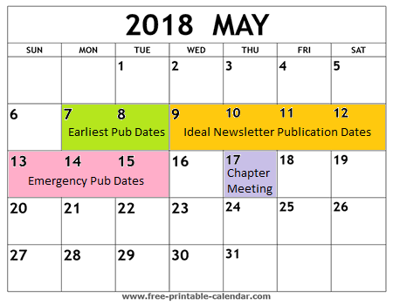

Writer Feedback Deadline
Authors deserve a chance to view and respond to your editorial recommendations. Likewise, you deserve a chance to request additional help from authors to make their articles the best they can be.
Plan a due date for author feedback to your editorial recommendations. This should be at least two days before you plan to publish MtM. This gives you time to review changes from authors, and to start a dialogue if necessary. Please note that responses to your edits should be mandatory. If you do not feel an author has fully responded to your edits (such as not replying to a comment that requests additional input from the author), you have the right to ask for a more thorough response.

Editorial Recommendations Deadline
Commit to editing all articles (and sending your edits to authors) at least two days before their feedback is due. Authors need sufficient time to look over your edits. The file format for edits is up to you, but most technical communicators are comfortable with Track Changes and Comments in Microsoft Word.

Article Submission Deadline
Set a due date for articles at least two days before your edits will be due back to authors. This will give you time to thoroughly review all submissions.
Please keep in mind that some authors may be late in submitting their articles. Unfortunately, denying an article’s admission into MtM due to lateness may not always be an option. Some topics may be critical and time-sensitive.
Your best tool for averting a schedule crisis is communication with authors. Start early and communicate frequently. Announce your publication timeline well ahead of time, and solicit articles as soon as you can. The previous month’s chapter meeting is a good time to get the ball rolling. Then, follow up with authors every two or three days to check on progress and remind everyone of deadlines.

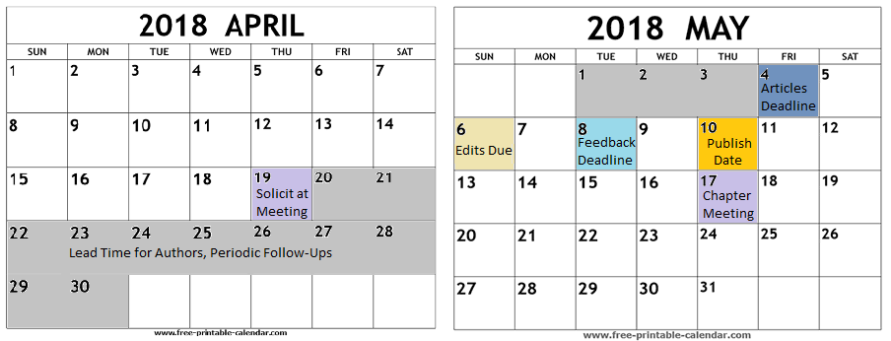

Articles for the Newsletter
MtM has several established columns you can count on for content every month. Some of these are even required in accordance with our chapter bylaws—specifically The President’s Corner, This Month’s Meeting, and If You Missed the Last Meeting. Here is a typical layout for a volume of Memo to Members:
- Table of Contents
- From the Editor’s Desk
- The President’s Corner
- This Month’s Meeting
- If You Missed the Last Meeting or XYZ Meeting Recap
- Feature Article 1
- Feature Article 2

Table of Contents
The Table of Contents (TOC) post is always titled according to the month and year (Example: May 2018). It includes our standard newsletter banner and logo, as well as links to all other articles in the MtM volume. This is the last post you will want to draft in each volume. The process for this is explained in the next section, Newsletter Publication (Wordpress).

From the Editor’s Desk
This column is always the first to follow the TOC. You have three goals with this column: to be your authentic self, to briefly plug the upcoming chapter meeting (make sure to include an RSVP link), and to briefly summarize what the audience will read throughout the rest of the MtM volume.

The President’s Corner
This column is always written by the President, and it can be about almost anything. Presidents typically use this as an opportunity to announce new developments/accomplishments in the chapter (be careful not to steal their thunder!), for various public service announcements, or to further plug the upcoming meeting. Some months, they might exercise a bit of creative freedom, writing that only tangentially relates to technical communication.

This Month’s Meeting
This column is always written by the Vice President, and it plugs the upcoming chapter meeting in as much detail as possible. It was previously known as A View from Number Two, but has been rebranded to make its purpose clear.

If You Missed the Last Meeting
This column is usually written by the Secretary, and it recaps the chapter meeting from the previous month. If the secretary is not going to be present at the meeting, it is your responsibility to ask someone else to take notes at the meeting so they can step in to write the article. You must also ensure that someone is taking photos at the meeting, as it will be the author’s job to incorporate photos and captions into the article. Consider setting an earlier deadline for this article so that the author can write it while meeting events are fresh in their mind.

Feature Articles
From time to time, you or someone else in the chapter might have something else to share with MtM readers. This is most welcome, as it adds a little variety to an otherwise routine publication. Although these are not required, it is nice to have one or two for each volume. Examples below:
- Example 1, What We Believe Shapes What We Do
- Example 2, Student Volunteering at the STC Summit: Free Registration and Networking
- Example 3, 2017-2018 Mentoring Program off to a Rousing Start: Year 15 of an STC Benchmark Program

Occasional Guest Columns
We also have semi-regular columns that just come up on occasion. Our most frequent guest column in 2018 has been The View from Campus, written by members of the FTC club at UCF. In addition, there is the Treasurer’s column titled Fun with Numb3rs, and an aptly-named Tool Tips column. (There is a Master List post for Tool Tips. Please add to it whenever a new Tool Tips article is published.)

New Columns on the Horizon?!
This newsletter has experimented with new columns in the past, and you should feel empowered to do so, too! Is there someone who has an interest in writing for MtM on a regular or semi-regular basis? Great! Here are some regular columns we had in the past:
- On the Record, a column full of engaging interviews with chapter members
- Spotlight on Excellence, a column about values and their relation to a writer’s excellence

Newsletter Publication (WordPress)
Publishing the newsletter may seem daunting at first, but it becomes routine after a few months of practice. This section covers the drafting and blog-style publication process of MtM in WordPress.

Drafting an MtM Volume
To draft a volume of MtM, perform the following procedure:
- Log in to WordPress at http://memotomembers.stc-orlando.org/wp-login.php.
- Click Posts Categories to enter a new category for this new volume of MtM in the Name box. The naming convention for your category must be precise in order to keep the columns listed chronologically: Volume yyyy-mm (this remains true even if a month is skipped). Examples include Volume 2018-05 (typical layout), as well as Volume 2018-05a and Volume 2018-05b (if for some reason there were a two-part volume).
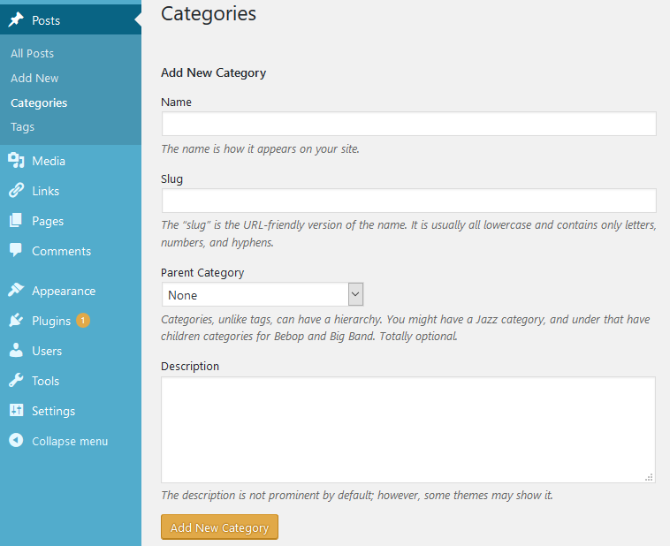
- Add a lower-case, URL-friendly “Slug” in the Slug box with the following naming convention: month-yyyy. Examples include may-2018 (typical layout) and may-2018-part-2 (if for some reason there were a two-part volume).

- Click Posts All Posts on the Dashboard to assess current posts.

- Click Add New button. There is a button on the All Posts page and in the left-hand side bar (both highlighted below).
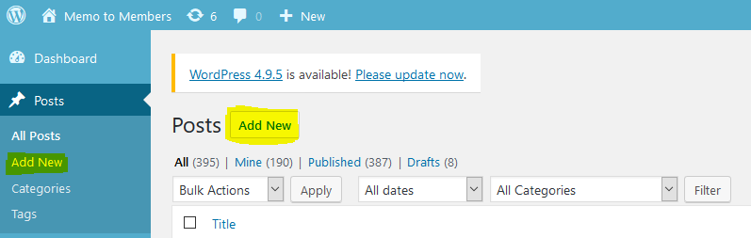

- In the Add New Post screen, click Visual tab at top-right of the message content box.
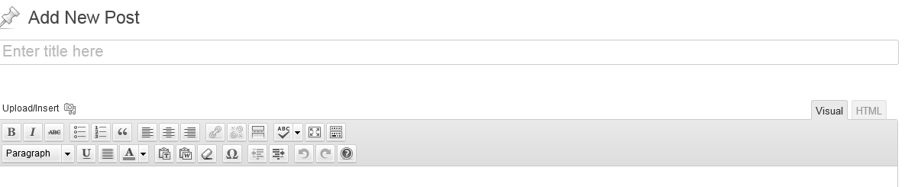
- Open the file with the article you want to post. In this case, it is The President’s Corner.
- Select and copy article text.
- Paste content from the article file into the content box. Note that formatting (bold, italics, hyperlinks, etc.) from the content will paste into the content box as well, so you can format articles in a separate program and then paste them in.
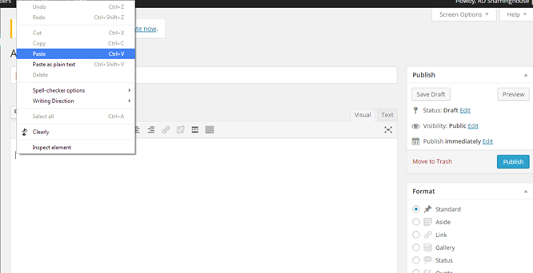
- Click Save Draft often. Losing your work will be frustrating from this point on.
- Click Preview at will to open your article in another tab. You will be able to see it from a reader’s view this way.
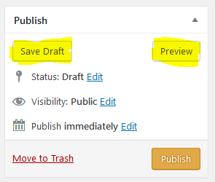

- Fill out title box.
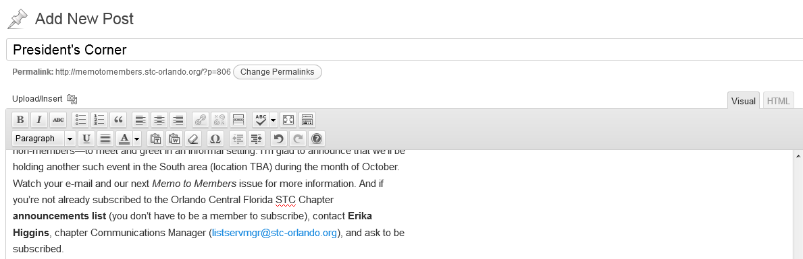
- Fix formatting issues such as extra line breaks. You can use the editing toolbar to add links and make other formatting changes. (Ensure that the Toolbar Toggle button is selected for full menu access.)
- Add photos and other images to your post using the Add Media button. From there, you can upload images to the media library, insert them into posts, and edit their display size, alignment, and caption text.
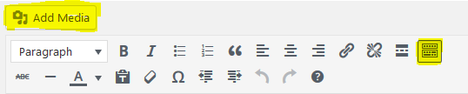
- Wordpress will automatically generate a Permalink for the article. Select, copy, and paste this permalink in a separate file, along with the article title. This will help you fill out your Table of Contents post later.
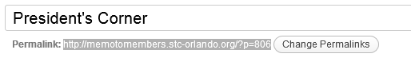
- In the categories area of the authoring page, you can click Add New Category if the month you are publishing is not already in the list. However, you will need to add a Slug later in accordance with Step 1. If the category is already in the list, select it.
- Also add the new post to the Current Issue category. (Later on, remember to move all previous volume articles from the Current Issue category to the All Archived Volumes category.)
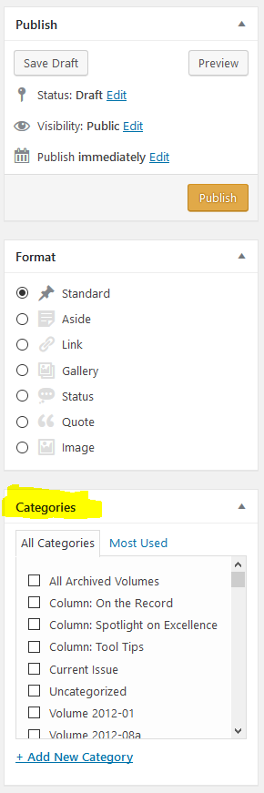
- If you need to change something, then keep editing; save as a draft and preview until satisfied. DO NOT CLICK PUBLISH YET.
- Return to All Posts page. You should now see your new post listed as a draft.
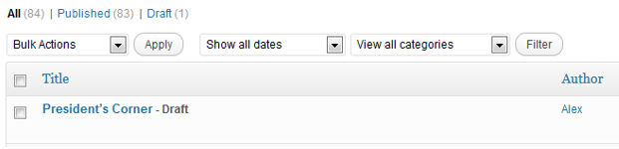
- Repeat steps 5–19 for all articles in the issue until you have all the drafts you need. DO NOT PUBLISH THEM YET.
- Now, create a Table of Contents (TOC) as follows:
  - Click on another TOC (in this case, April 2018).

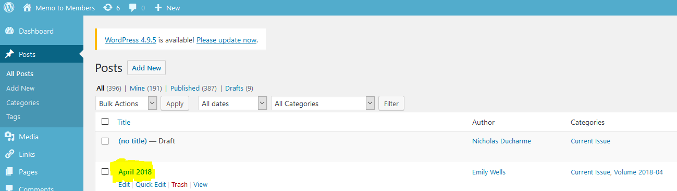

  - Click the Text tab, next to the Visual tab.
  - Select and copy all text in the post.
  - Exit this post without saving any changes and create a New Post.
  - Fill out Title and Category fields.

  - In the message content box, paste all text copied from the other TOC post.
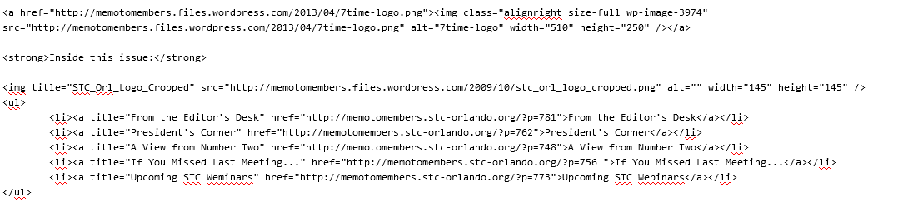
  - In the <ul> section, each <li> element is a bulleted link to an article. Each <li> contains a hyperlink <a> that contains a title, an href, and the display text.
  - The usual article order is as follows, but can be changed per your best judgement.
    - From the Editor’s Desk
    - President’s Corner
    - This Month’s Meeting
    - If You Missed the Last Meeting
    - Feature Article 1 (title varies)
    - Feature Article 2 (title varies)
NOTE: KEEP TRACK OF THIS ORDER. TO MAKE THE BLOG APPEAR AS A FLOWING NEWSLETTER, YOU MUST PUBLISH IN REVERSE ORDER, WITH THE TOC BEING PUBLISHED LAST, BUT APPEARING “FIRST.”
  - From the document where you took notes of permalinks, fill in the href=“…” portion of each <li> with each permalink.
  - Fill in the Title and the display text for each URL. They must match.
  - Click Save Draft. Preview your Table of Contents (TOC) and test the links. Keep Preview tab open to TOC to aid in publishing.
  - Click All Posts to return to the screen with all your drafts.

Publishing an MtM Volume
To publish a volume of MtM once it is drafted, perform the following procedure:
- Using the preview of the TOC post as a reference, select the draft of the bottom post in the TOC. CLICK PUBLISH.
- Repeat publishing process from the bottom of the table of contents to the table of contents draft itself. In the example below, The View from Campus would be published first, followed by New Benefit for Student Members from STC Florida, etc. 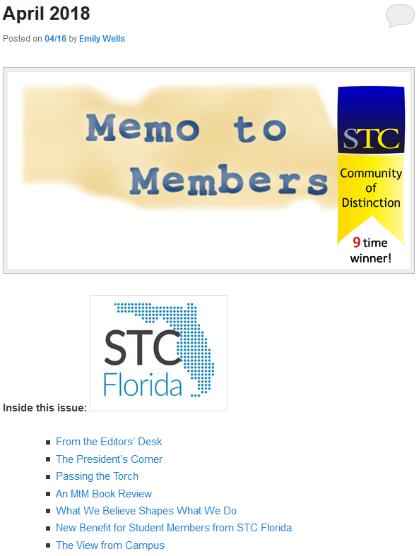

- Keep the URL of your new publication on hand. You will need it for MailChimp distribution.
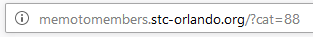

Newsletter Distribution (MailChimp)
Distributing the newsletter is far less time-consuming than publishing it, but also far more prone to user error. Luckily, this guide is here to help! This section covers the distribution of MtM to its primary audiences: our distribution lists on MailChimp.
You will be sending out two email blasts for each volume of MtM. One will go to our full Chapter Announcements list, and one will go to our full STC Florida’s Newsletter Distribution to Other STC Chapters list. The two distributions will be nearly identical, with just slightly different wording in the message body. It is recommended that you start with the former, as this will help prepare you for the latter.
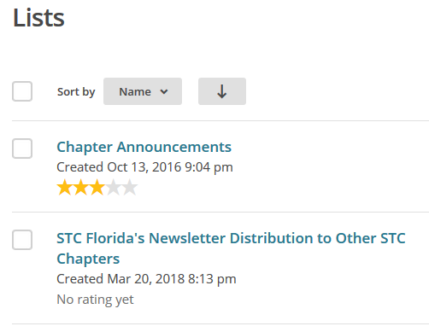
To distribute MtM with MailChimp, perform the following procedure:
- Log in to MailChimp at https://login.mailchimp.com/.
- Click Templates on the top-left menu bar.

- Select between the MtM Newsletter Distribution and MtM Newsletter Distribution (Other Chapters Only). The former is for our full Chapter Announcements list, and the latter is for our full STC Florida’s Newsletter Distribution to Other STC Chapters list. Therefore, you should start with the former.
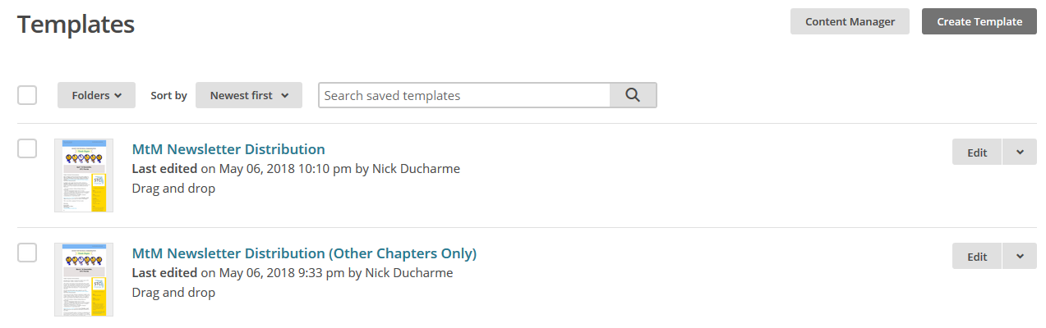
- Review the template and prepare to make updates. Keep in mind that any changes will be autosaved every 20 seconds, and that there is no undo button.
- Edit the template. TRIPLE-CHECK TO MAKE SURE ALL FIELDS ARE APPROPRIATELY UPDATED. It is notoriously easy to miss a date or link and send outdated information. Here are some commonly-missed fields:
- Link to current MtM volume in body
- Meeting advertisement in body
- RSVP link in body (not present in STC Florida’s Newsletter Distribution to Other STC Chapters list)
- RSVP Now button below body
(not present in STC Florida’s Newsletter Distribution to Other STC Chapters list)
- Meeting title in header bar, title bar, and side bar
- Meeting time and location in side bar
- Special Thanks/Active Membership message below body
(Articles are worth 1.0 Active Membership points, and From The Editor’s Desk does not count)
- Copyright year in footer
(Remember to update in January)

- Click Save and Exit at the bottom-right corner of the page when you are finished with updates.
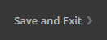
- Click the drop-down arrow and Create campaign for the desired template on the Templates page.
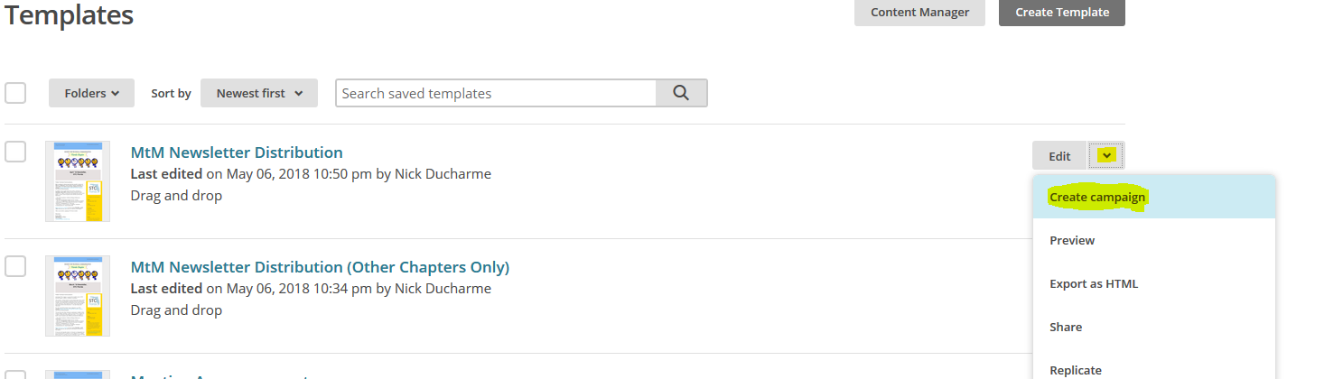
- Fill out title field. This is just a campaign title for internal tracking purposes. You can open the Campaigns page in a new tab or new window from the top-left sidebar to view past campaigns we have sent. This will help you achieve consistency.
- Fill out To field per the criteria outlined in step 3.
- Fill out From field. It consists of two subfields:
- Name subfield: STC Florida Chapter is sufficient for the general MtM distribution. Florida Chapter, Society for Technical Communication is more appropriate for our distribution to other chapters.
- Email Address subfield: This should always be newsletter@stc-orlando.org.
- Fill out Subject field. This determines the email’s subject line and preview text. You can open the Campaigns page in a new tab or new window from the top-left sidebar to view past campaigns we have sent. This will help you achieve consistency for the Subject and Preview Text subfields.
- Preview your message if you wish, but DO NOT USE THE EDIT DESIGN FUNCTION. If you realize you need to make additional changes to the message itself, click Finish Later near the top-right corner of the page and go back to edit the template. This will ensure that the template is up to date.

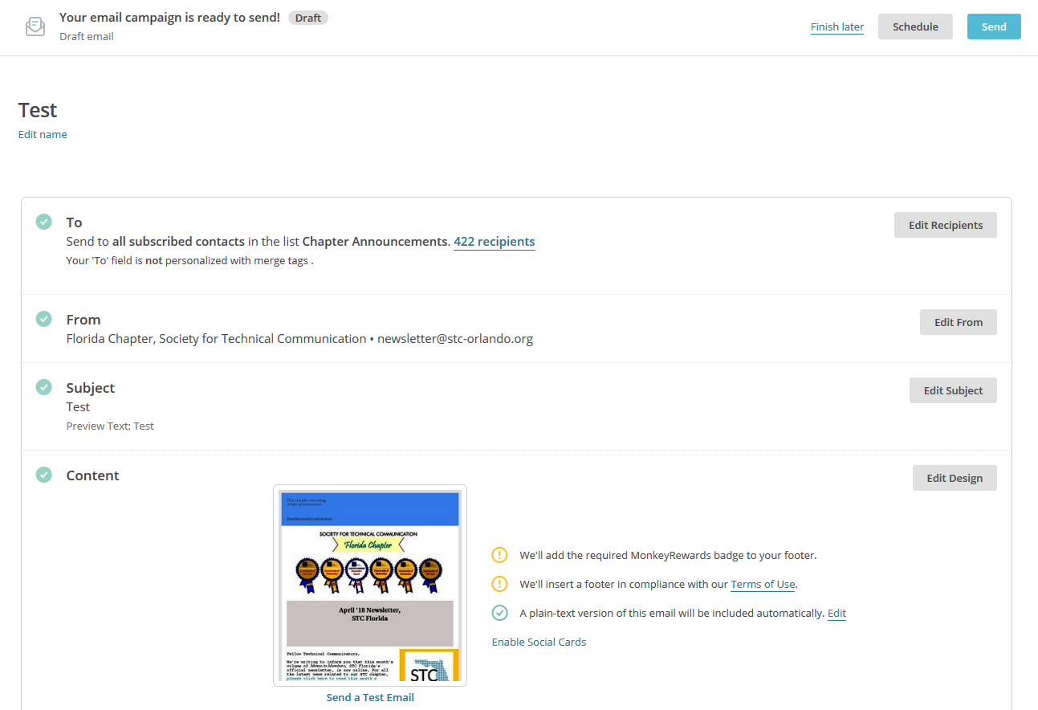
- When you are ready to distribute the message, click Schedule or Send near the top-right corner of the page. Schedule is ideal if you want to plan the message for a later time/date. Send is ideal if you are ready to send the message immediately.
- If you click Send, you will be prompted to confirm. Click Send again, and you will be taken to a congratulatory page for sending off your campaign. If you click Schedule instead, please update this guide with your findings! This function has not yet been tested.
- Now, repeat steps 2–14 to complete this process again for the second list.

